**FORMAT-CON-4**

**APPLICATON FORM FOR ADDITIONAL INFORMATION TO BE**

**FURNISHED FOR SIGNING CONNECTION AGREEMENT TO**

**INTER-STATE TRANSMISSION SYSTEM**

**General Information to the Applicants**

1. Applicant given intimation for Connectivity to the gridby the CTUas per **FORMATCON-3** shall have to furnish additional details to CTU for signing of “Connection Agreement” as per the enclosed format..
2. The CTU will process the information provided in this format and will intimate the Connection details as per format given at **FORMAT-CON-5.** Pursuant to such Connection details, the applicant shall have to sign “Connection Agreement” with CTU prior to the physical inter-connection as per format given at **FORMAT-CON-6**. In case the connectivity is granted to the ISTS of an inter-State transmission licensee other than the CTU, a tripartite agreement shall be signed between the applicant, the Central Transmission Utility and such inter-State transmission licensee, in line with the provisions of the Regulations. After signing of the Agreement, Nodal Agency will provide a copy of the same to concerned SLDC/RLDC.

**ADDITIONAL INFORMATION TO BE FURNISHED TO CTU FOR SIGNING OF “CONNECTION AGREEMENT” FOR CONNECTION TO INTER-STATE TRANSMISSION SYSTEM**

1. **DETAILS OF APPLICANT**

|  |  |  |  |  |  |
| --- | --- | --- | --- | --- | --- |
| 1. | Name of the Applicant Company | : |  | | |
| 2. | Details of Grant of Connectivity (a) Connectivity Intimation No. (b) Date |  |  | | |
| 2. | Address for Correspondence | : |  | | |
| 3. | Contact Person  3.1 Prime Contact Person   1. Name 2. Designation (c) Phone No. 3. FAX 4. E-mail     9.4 Alternate Contact Person   1. Name 2. Designation (c) Phone No. 3. FAX 4. E-mail | : |  | | |
| 4. | Status of Applicant Company (Please tick the appropriate box) | : |  |  | Generating Station including  Captive generating plant    Bulk Consumer |
|  |
| 5. | Estimated time of completion of project  (Please enclose PERT chart) |  |  | | |

1. **MAPS AND DIAGRAMS**

* 1. Provide necessary survey of India topo sheet clearly marking the location of the proposed site. **Schedule - I**
  2. Provide site plan (both hard and soft copy in AutoCAD 2000 & above version) in appropriate scale. **Schedule – II.** The site plan should indicate following details
     1. The proposed location of the connection point
     2. Generators
     3. Transformer
     4. Site building

* 1. Provide an electrical Single Line Diagram (SLD) of the proposed facility detailing

all significant items of plant. The plan is to be submitted in both hard copy and soft copy in AutoCAD 2000 & above version **Schedule - III**

1. **DETAILS OF CONNECTION - GENERATION PLANT**

|  |  |  |  |
| --- | --- | --- | --- |
| 1. | Type of Generation Plant (Hydro, Thermal,  Gas etc | : |  |
| 2. | Rating of Generator Units | : | **Schedule – IV** |
| 3. | Maximum Export Capacity Required | : |  |
| 4. | Maximum Import Capacity required  This is the amount of import capacity that the site will require during startup (MVA) | : |  |
| 5. | Station house load during normal operating conditions (MW/MVAR) | : |  |
| 6. | Expected running regime e.g. base load, peaking etc | : |  |
| 7. | Generator Data for Fault (Short Circuit  Studies) |  | **Schedule – V** |
| 8. | Dynamic Simulation Data  Generator  Excitation Power System Stabilizer |  | **Schedule – VI**  **Schedule – VII**  **Schedule – VIII** |

1. **DETAILS OF CONNECTION – BULK CONSUMER**

|  |  |  |  |
| --- | --- | --- | --- |
| 1. | Type of Load (Industrial/Commercial) including type of industry, i.e. electric furnace, rolling mills, manufacturing, assembly line, etc. | : |  |
| 2. | Peak requirement of load in MVA, MW and  MVAR | : |  |
| 3. | Peak import required in MVA, MW and  MVAR | : |  |
| 4. | Month-wise Peak import required in MVA,  MW and MVAR | : |  |
| 5. | Month-wise Energy requirement in MUs. | : |  |
| 6. | Data for Fault (Short Circuit Studies) |  | Single phase and three phase Fault level |
|  |  |  |  |

1. **DETAILS OF CONNECTION – DATA AND VOICE COMMUNICATION**

|  |  |  |  |
| --- | --- | --- | --- |
| 1. | Type Data Gateway  ( Remote Terminal Unit/ Substation  Automation System Gateway) | : | (Whether RTU/ Substation Automation System Gateway ; and Number of data ports) |
| 2. | Data Communication connectivity Standard followed  (As per interface requirement and other  guideline made available by the respective  RLDC) | : | (Type of Communication Protocol, i.e.  101(serial port) or 104(Ethernet), etc.) |
| 3. | Write here the communication media, interface and capacity being targeted for connection for Data and voice  Communication | : | (Communication media: For example fibre optics, PLCC, etc.  Interface : Example RS 232C, G.703) or as per mutual agreement  Capacity : 1200 baud, 64 Kbps, 9.6 Kbps, etc as per mutual agreement) |

1. **DETAILS OF CONNECTION – SOLAR PV STATION**

**Models for Utility scale Solar generation farms:**

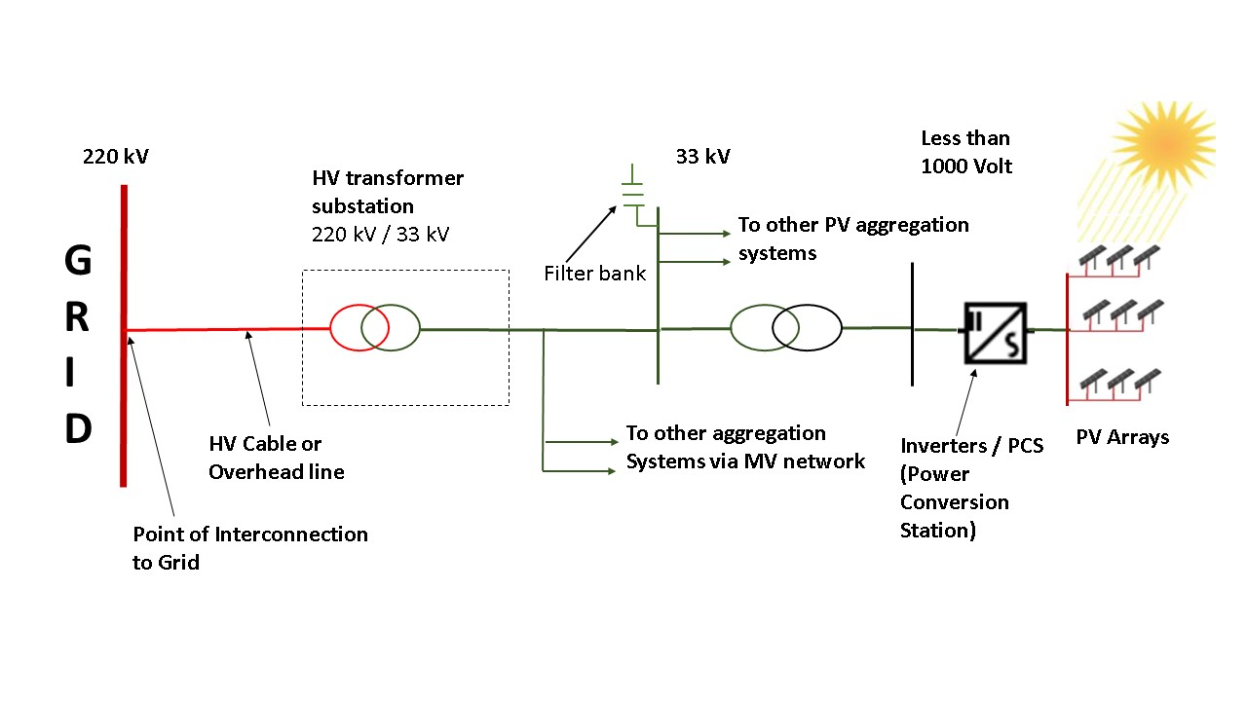

In a typical utility scale solar farm / park, arrays of Solar PV panels connected to an inverter (Power Conditioning System / Power Conversion Station – PCS), which is stepped up to form part of the MV reticulation system (typically at 33 kV or less). A number of inverters are pooled and then stepped up to the voltage of 220 kV / 400 kV prior to connection to EHV grid. A Power Plant controllers (PPC) is usually installed at the point of interconnection to grid or the reticulation system. The PPC(s) control behavior of solar farms in accordance with mandates as per grid codes.

The dynamic components of a solar farm or park consists of the following elements (illustrated in picture below):

1. Generator or Converter
2. Electrical control including fault ride through
3. Power Plant Controller (PPC)
4. Energy storage (i.e. battery), if applicable

Depending on the nature of technology and usage of components at site, the requirements for steady state and dynamic modelling evolves.

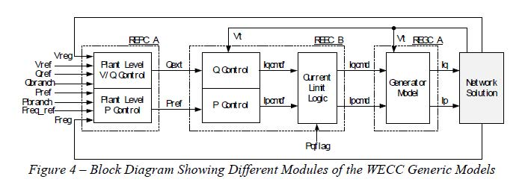

For CTU to have access to fit-for-purpose models of Solar farms/ parks connected to Indian grid, the following information shall be provided:

1. Electrical Single Line Diagram(SLD) of Solar farm /park depicting:
   * For individual Inverters / Power Condition system (PCS): Type, MW rating, MVAR capability, temperature dependent capability curves, short circuit contribution, Manufacturer, Model no., Harmonic profile of inverters
   * Configuration and Details of PV arrays behind each inverter / PCS
   * Reticulation system (MV system within the solar farm): Length of individual branch / twig, Type of conductor, Electrical parameters (R, X, B)
   * Details of MV (~660V/33kV) and HV (~33kV/220kV) step-up transformers: Rating, Impedance, Vector Group, Tap changers (Type, Tap Steps, Max Ratio and Min Ratio in p.u.)
   * Filters (active or passive) or capacitor banks
   * Aggregated steady state model validated for P injection and Q injection at the point of interconnection.
2. Generic models of Solar farms (**Refer Schedule - IX**)
   * Models should be suitable for an integration time step between 1ms and 20ms, and suitable for operation up-to 600s.
   * Including a Generic Power Plant Controller (PPC) model which represents the interaction of power plant with the grid. Settings of the Power Plant Controller may be tuned as per the existing setup on field.
   * Simulation results depicting validation of Generic models against User-Defined models (for P, Q, V, I) and against actual measurement (after commissioning) to be provided.
3. Encrypted user-defined model (UDM) in a format suitable for use in latest release of PSS/E (*.dll files) for electromechanical transient simulation for components of Solar farm: (in case of non-availability of validated generic model)
   * User guide for Encrypted models to be provided including instructions on how the model should be set-up
   * Corresponding transfer function block diagrams to be provided
   * Simulation results depicting validation of User-Defined models against actual measurement (P, Q, V, I) to be provided
   * The use of black-box type representation is not preferred.
   * Models should be suitable for an integration time step between 1ms and 10ms, and suitable for operation up-to and in excess of 100s.
4. Inverter datasheet
5. Voltage/reactive control strategy of farm, reactive capability curves at point of interconnection (temperature and voltage dependence)
6. Settings from an inverter / PCS (each model in the farm)
   * Mapping of settings from the inverter/PCS to the model (UDM and Generic)
7. Settings from the Power plant controller (PPC)
   * Mapping of settings from the inverter/PCS to the model (UDM and Generic)
8. Disturbance recordings – of Solar farm response to disturbance together with any associated information about the circumstances of the disturbance
9. **DETAILS OF CONNECTION – WIND GENERATING STATION**

**Models for Wind generators:**

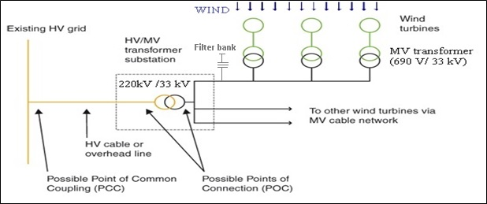

In a typical wind farm / park, individual WTGs (typically rated 3 MW or less) are connected in a system of twigs and feeders. Wind generation at around 660 V / 690 V is stepped up to a MV level of typically 33 kV in Indian system and finally pooled to grid at 220 kV / 400 kV through step-up transformers. A typical wind farm of 300 MW will be spread over an area of 600 acres, and power transmission within the farm is typically at 33 kV through overhead lines or underground cables. A Power Plant controllers (PPC) is usually installed at the point of interconnection to grid or at the reticulation system. The PPC(s) control behavior of wind farms in accordance with mandates as per grid codes.

The dynamic components of a wind farm consist of the following elements (illustrated in picture below):

1. Generator or Converter
2. Electrical control
3. Drive-Train model
4. Aerodynamics
5. Pitch controller
6. Torque controller
7. Power Plant Controller (PPC)
8. Energy storage (As applicable)

The components may or may not be present depending on the nature of technology used for wind power generation (i.e. type of turbine). Depending on the nature of technology, usage/configuration of components at site, the requirements for steady state and dynamic modelling evolves.

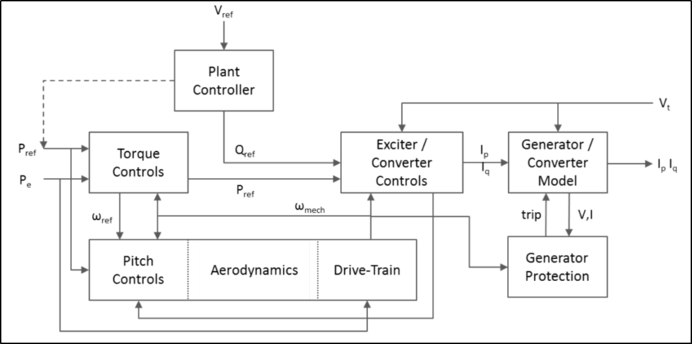

For CTU to have access to verified fit-for-purpose models of wind farms/ parks connected to Indian grid, the following information shall be provided:

1. Electrical Single Line Diagram (SLD) of Wind farm /park depicting:
   * For individual WTGs: Type, MW rating, MVAR capability, Manufacturer, Model no., capability curve
   * Reticulation system (MV system within the wind farm): Length of individual branch / twig, Type of conductor, Electrical parameters (R, X, B)
   * Filters (active or passive) or capacitor banks
   * Details of MV (690V/33kV) and HV (33kV/220kV) step-up transformers: Rating, Impedance, Vector Group, Tap changers (Type, Tap Steps, Max Ratio and Min Ratio in p.u.)
   * Aggregated steady state model validated for P injection and Q injection at the point of interconnection.
2. Generic models of WTGs / Wind farms (Refer **Schedule - X**)
   * Models should be suitable for an integration time step between 1ms and 20ms, and suitable for operation up-to 600s.
   * Including a Generic Power Plant Controller (PPC) model which represents the interaction of power plant with the grid. Settings of the Power Plant Controller may be tuned as per the existing setup on field.
   * Simulation results depicting validation of Generic models against User-Defined models (for P, Q, V, I) and against actual measurement (after commissioning) to be provided.
3. Encrypted user defined model (UDM) in a format suitable for latest release PSS/E (*.dll files) for electromechanical transient simulation for components of WTGs / Wind farm (in case non-availability of validated generic model)
   * User guide for Encrypted models to be provided including instructions on how the model should be set-up
   * Corresponding transfer function block diagrams to be provided
   * Simulation results depicting validation of User-Defined models against actual measurement (for P, Q, V, I) to be provided
   * The use of black-box type representation is not preferred.
   * Models should be suitable for an integration time step between 1ms and 10ms, and suitable for operation up-to and in excess of 100s.
4. Wind Turbine datasheet
5. Voltage/reactive control strategy of farm, reactive capability curves at the point of interconnection (Temperature and Voltage dependence)
6. Settings from a wind turbine (each model in the farm)
   * Mapping of settings from a wind turbine to the corresponding model (both UDM and generic)
7. Settings from the Power plant controller (PPC)
   * Mapping of settings from PPC to the corresponding model (UDM and Generic model)
8. Disturbance recordings – of wind farm response to grid disturbance together with any associated information about the circumstances of the disturbance

**This is to certify that the above data submitted with the application are pertaining to connection sought for the ISTS. Further, any additional data sought for processing the application shall be furnished.**

**Authorized Signatory Of Applicant**

**Name :**

**Designation :**

**Seal :**

**Place :**

**Date :**

**Schedule – I : Survey of India topo sheet clearly marking the location of the proposed site**

**Schedule – II : Site plan in appropriate scale.**

**Schedule – III : Electrical Single Line Diagram (SLD) of the proposed facility detailing all significant items of plant.**

**Schedule – IV : Rating of Generating Units**

(Add additional sheets if number of units are more)

|  |  |  |  |  |
| --- | --- | --- | --- | --- |
|  |  | Unit – 1 | Unit - 2 | Unit – 3 |
| 1. | Unit Rating (MVA) |  |  |  |
| 2. | Normal Max. Continuous Generation Capacity at  Normal operating temperature (MW) |  |  |  |
| 3 | Normal Max. Continuous Export Capacity at Normal operating temperature (MW) |  |  |  |
| 4 | Maximum (Peaking) generating Capacity at min ambient air temperature (MW) |  |  |  |
| 5 | Maximum (Peaking) Export Capacity at min ambient air temperature (MW) |  |  |  |
| 6 | Minimum Continuous Generating Capacity (MW) |  |  |  |
| 7 | Minimum Export Generating Capacity (MW) |  |  |  |
| 8 | Normal Maximum Lagging MVAR at rated MW output |  |  |  |
| 9. | Normal Maximum leading MVAR at rated MW output |  |  |  |

Please attach a capability Curve : __________________________

Drawing no. of the Capability

Diagram attachment

**Schedule – V : Generator Data for Fault (Short Circuit Studies)**

All data to be provided on pu machine MVA base

|  |  |  |  |
| --- | --- | --- | --- |
| 1. | Direct Axis Transient Reactance  (Unsaturated) | Xd‟ |  |
| 2. | Sub-transient Reactance (Unsaturated) | Xd” |  |
| 3. | Synchronous Reactance | Xs |  |
| 4. | Zero Phase Sequence Reactance | Xo |  |
| 4. | Negative Phase Sequence Reactance | X2 |  |

**Schedule – VI : Dynamic Simulation Data**

**Generator Data**

All data to be provided on pu machine MVA base

|  |  |  |  |
| --- | --- | --- | --- |
| 1. | Direct Axis Positive Phase Sequence  Synchronous Reactance | Xd |  |
| 2. | Quadrature Axis Positive Phase Sequence Synchronous  Reactance | Xq |  |
| 3. | Direct Axis Transient Reactance (unsaturated) | Xd‟ |  |
| 4. | Quadrature Axis Transient Reactance (unsaturated) | Xq‟ |  |
| 5. | Sub-Transient Reactance (unsaturated) | Xd‟‟ |  |
| 5. | Armature Leakage Reactance | X*l* |  |
| 6. | Direct Axis Transient open circuit Time Constant (Secs) | Tdo‟ |  |
| 7. | Direct Axis Subtransient open circuit Time Constant(Secs) | Tdo‟‟ |  |
| 8. | Quadrature Axis Transient open circuit Time Constant(Secs) | Tqo‟ |  |
| 9. | Quadrature Axis Subtransient open circuit  Time Constant(Secs) | Tqo‟‟ |  |
| 10. | Inertia of complete turbogenerator (MWs/MVA) | H |  |
| 11. | Please provide open circuit magnetization curve enter drawing number here or mention “assume”  *if this not available then POWERGRID shall assume magnetic*  *saturation characteristics as per the* ***Annexure-I*** |  |  |

**Excitation Data**

Please submit Laplace domain control block diagram that represents the generator excitation system in accordance with the IEEE standard excitation model or as otherwise agreed with POWERGRID. This control block diagram should completely specify all the time constants and gains to fully explain the transfer function from the compensator or generator terminal voltage and field current to generator voltage. A list of acceptable IEEE standard excitation model available with PSS/E simulation package used by POWERGRID is shown in **Annexure-II**.

Please fill/tick the appropriate box below:

|  |
| --- |
| model |

Please assume

OR

If the excitation data is not available at this stage then POWERGRID shall assume exciter model given at **Annexure-III** which represents a typical excitation model.

|  |
| --- |
|  |

Assume the model given at **Annexure-III** as our model

**Schedule – VII: Two Winding Transformer Data**

|  |  |  |
| --- | --- | --- |
| 1. | Transformer positive sequence resistance (R1%) |  |
| 2. | Transformer positive sequence reactance (X1%) |  |
| 3. | Transformer zero sequence resistance (R0%) |  |
| 4. | Transformer zero sequence reactance (X0%) |  |
| 5. | Transformer Vector group |  |
| 5. | Nature of Tap Changer (on load/off load) |  |
| 6. | Number of steps and step size |  |

**Schedule – VIII: Three Winding Transformer Data**

|  |  |  |
| --- | --- | --- |
| 1. | Transformer Vector group |  |
| 2. | Positive sequence resistance (R1HL1%) between HV/LV1 |  |
| 3. | Positive sequence reactance (X1HL1%) between HV/LV1 |  |
| 4. | zero sequence resistance (R0HL1%) between HV/LV1 |  |
| 5. | zero sequence reactance (X0HL1%) between HV/LV1 |  |
| 6. | Positive sequence resistance (R1HL2%) between HV/LV2 |  |
| 7. | Positive sequence reactance (X1HL2%) between HV/LV2 |  |
| 8. | Transformer zero sequence resistance (R0HL2%) between HV/LV2 |  |
| 9. | zero sequence reactance (X0HL2%) between HV/LV2 |  |
| 10. | Positive sequence resistance (R1L1L2%) between LV1/LV2 |  |
| 11. | Positive sequence reactance (X1L1L2%) between LV1/LV2 |  |
| 12. | zero sequence resistance (R0L1L2%) between LV1/LV2 |  |
| 13. | zero sequence reactance (X0L1L2%) between LV1/LV2 |  |
| 14. | Positive sequence resistance (R1HL1//L2%) between HV/(LV1+LV2) |  |
| 15. | Positive sequence reactance (X1HL1//L2%) between HV/(LV1+LV2) |  |
| 16. | zero sequence resistance (R0HL1//L2%) between HV/(LV1+LV2) |  |
| 17. | zero sequence reactance (X0HL1//L2%) between HV/(LV1+LV2 |  |

**Schedule – IX: Generic Models of Solar Farms**

**1.1 Generic models in PSS/E for modelling utility scale Solar PV installations:**

|  |  |  |
| --- | --- | --- |
| **Solar Technology** | **Generic model** | **Model Description** |
| Utility Scale Solar PV | REGCA1 | Renewable energy generator converter model |
| REECA1 | Renewable energy controls model |
| REPCA1 | Renewable energy plant controller |
| Utility Scale Battery Energy Storage System (BESS) | REECCU1 | Electrical Control Model  (To be used along with REGCA1 and REPCA1) |

Refer Annexure – IV for Detailed block diagrams of the above models

**Details of models in PSS/E for modelling Solar plants / farms / parks:**

|  |  |  |
| --- | --- | --- |
| **Category** | **Parameter Description** | **Data** |
| Inverter Details | Manufacturer, model number and product details |  |
| Year of commissioning |  |
| As found settings (obtained either from HMI or downloaded from controller in digital systems) |  |
| Technology | • Grid following  • Grid forming (viz. Assist in regulation of Voltage and Frequency)  • Reactive power priority (Controls Pf or Voltage? Point of control?) |  |
| Single Line Diagram | Single line diagram of the solar farm showing number and location of inverters and PV arrays behind each inverter, cable run, transformers, feeders (including type of cables and electrical R,X,B parameters), and connection to transmission system  Preferable : Electrical Single Line Diagram including details between PV-array to Inverters, Inverters to MV reticulation system, MV reticulation system till Point of Interconnection (POI) at EHV level (220 kV/400 kV) |  |
| Capability | DC/AC ratio |  |
| Number of inverters |  |
| Panel type |  |
| Number of modules per string |  |
| Tracking in 0/1/2 axes |  |
| Capability diagram at nominal (STC) and typical temperature |  |
| Controls | Does the solar farm have a PPC? If yes, whether PPC controls all or part of the inverters in Solar farm |  |
| What is the method of control – voltage regulation, power factor control, reactive power control? |  |
| Voltage control strategy (operating mode)   * Controls MV bus * Controls HV bus * PF control * Q control |  |
| Is there a droop setting?   * Voltage control * Frequency control |  |
| Is reactive power limited? Details thereof |  |
| Is active power limited below MPPT at high output? Details thereof |  |
| Temperature dependency details |  |
| Active power ramp rate limiters |  |
| Fault Ride Through (FRT) protocols and setpoints  • LVRT  • HVRT |  |
| Provide settings from controller |  |

|  |  |  |
| --- | --- | --- |
| **Category** | **Parameter Description** | **Data** |
| Reticulation System | Voltage of the reticulation system |  |
| Number of feeders |  |
| Cable schedules (lengths, cable size, conductor material, rating info) |  |
| Inverter station transformer | Details of the turbine transformer, including vector group, impedance, and number of taps, tap position, tap ratio |  |
| Nameplate details |  |
| Solar Farm step-up transformer | Details of the main solar farm step up transformer, including vector group, impedance, and tap position |  |
| Nameplate ; OLTC? |  |
| Controlled bus |  |
| Voltage setpoint |  |
| Dead band |  |
| Number of taps |  |
| Tap ratio range |  |
| Connection Details | Voltage influence (maximum change etc) |  |
| Short circuit ratio (SCR) |  |
| ·          Min |  |
| ·          Max |  |
| Harmonic filters |  |
| STATCOM |  |
| Synchronous condensers |  |
| Battery Energy Storage System (if applicable) |  |
| Power Plant Controller (PPC) Details | Does the solar farm have a PPC? If yes, whether PPC controls all or part of the inverters in solar farm |  |
| What is the method of control – voltage regulation, power factor control, reactive power control? |  |
| Voltage control strategy (operating mode) - Controls MV Bus - Controls HV Bus - PF control - Q control - Voltage control |  |
| Is there a droop setting? - Voltage control - Frequency Control - Is there line drop compensation? |  |
| Is reactive power limited? |  |
| Temperature dependency |  |
| Active power ramp rate limiters |  |
| FRT protocols and setpoints - LVRT - HVRT |  |
| Provide settings from controller. |  |

**1.2 Generic Models for Utility Scale Solar-PV generation:**

|  |  |  |
| --- | --- | --- |
| **Category** | **Parameter Description** | **Data** |
| **GENERATOR model** | | |
| Solar PV (REGCA1) | Tg, Converter time constant (s) |  |
| Rrpwr, Low Voltage Power Logic (LVPL) ramp rate limit (pu/s) |  |
| Brkpt, LVPL characteristic voltage 2 (pu) |  |
| Zerox, LVPL characteristic voltage 1 (pu) |  |
| Lvpl1, LVPL gain (pu) |  |
| Volim, Voltage limit (pu) for high voltage reactive current manage- |  |
| Lvpnt1, High voltage point for low voltage active current management (pu) |  |
| Lvpnt0, Low voltage point for low voltage active current management (pu) |  |
| Iolim, Current limit (pu) for high voltage reactive current management (specified as a negative value) |  |
| Tfltr, Voltage filter time constant for low voltage active current management (s)- |  |
| Khv, Overvoltage compensation gain used in the high voltage reactive current management |  |
| Iqrmax, Upper limit on rate of change for reactive current (pu) |  |
| Iqrmin, Lower limit on rate of change for reactive current (pu) |  |
| Accel, acceleration factor (0 < Accel <= 1) |  |
| **Electrical Control model** | | |
| Large Solar PV : (REECB1)  [Refer Block Diagrams] | Vdip (pu), low voltage threshold to activate reactive current injection logic |  |
| Vup (pu), Voltage above which reactive current injection logic is activated |  |
| Trv (s), Voltage filter time constant |  |
| dbd1 (pu), Voltage error dead band lower threshold (≤0) |  |
| dbd2 (pu), Voltage error dead band upper threshold (≥0) |  |
| Kqv (pu), Reactive current injection gain during over and undervoltage conditions |  |
| Iqh1 (pu), Upper limit on reactive current injection Iqinj |  |
| Iql1 (pu), Lower limit on reactive current injection Iqinj |  |
| Vref0 (pu), User defined reference (if 0, model initializes it to initial terminal voltage) |  |
| Tp (s), Filter time constant for electrical power |  |
|  |  |

|  |  |  |
| --- | --- | --- |
| **Category** | **Parameter Description** | **Data** |
| **Electrical Control model** | | |
| Large Solar PV : (REECB1)  [Refer Block Diagrams] | QMax (pu), limit for reactive power regulator |  |
| QMin (pu) limit for reactive power regulator |  |
| VMAX (pu), Max. limit for voltage control |  |
| VMIN (pu), Min. limit for voltage control |  |
| Kqp (pu), Reactive power regulator proportional gain |  |
| Kqi (pu), Reactive power regulator integral gain |  |
| Kvp (pu), Voltage regulator proportional gain |  |
| Kvi (pu), Voltage regulator integral gain |  |
| Tiq (s), Time constant on delay s4 |  |
| dPmax (pu/s) (>0) Power reference max. ramp rate |  |
| dPmin (pu/s) (<0) Power reference min. ramp rate |  |
| PMAX (pu), Max. power limit |  |
| PMIN (pu), Min. power limit |  |
| Imax (pu), Maximum limit on total converter current |  |
| Tpord (s), Power filter time constant |  |

|  |  |  |
| --- | --- | --- |
| **Category** | **Parameter Description** | **Data** |
| **Power Plant Controller (PPC) model** | | |
| Generic Power Plant Controller (PPC) model:  (REPCA1) | Tfltr, Voltage or reactive power measurement filter time constant (s) |  |
| Kp, Reactive power PI control proportional gain (pu) |  |
| Ki, Reactive power PI control integral gain (pu) |  |
| Tft, Lead time constant (s) |  |
| Tfv, Lag time constant (s) |  |
| Vfrz, Voltage below which State s2 is frozen (pu) |  |
| Rc, Line drop compensation resistance (pu) |  |
| Xc, Line drop compensation reactance (pu) |  |
| Kc, Reactive current compensation gain (pu) |  |
| emax, upper limit on deadband output (pu) |  |
| emin, lower limit on deadband output (pu) |  |
| dbd1, lower threshold for reactive power control deadband (<=0) |  |
| dbd2, upper threshold for reactive power control deadband (>=0) |  |
| Qmax, Upper limit on output of V/Q control (pu) |  |
| Qmin, Lower limit on output of V/Q control (pu) |  |
| Kpg, Proportional gain for power control (pu) |  |
| Kig, Proportional gain for power control (pu) |  |
| Tp, Real power measurement filter time constant (s) |  |
| fdbd1, Deadband for frequency control, lower threshold (<=0) |  |
| Fdbd2, Deadband for frequency control, upper threshold (>=0) |  |
| femax, frequency error upper limit (pu) |  |
| femin, frequency error lower limit (pu) |  |
| Pmax, upper limit on power reference (pu) |  |
| Pmin, lower limit on power reference (pu) |  |
| Tg, Power Controller lag time constant (s) |  |
| Ddn, droop for over-frequency conditions (pu) |  |
| Dup, droop for under-frequency conditions (pu) |  |

|  |  |  |
| --- | --- | --- |
| **Category** | **Parameter Description** | **Data** |
| **Electrical Control model : BESS** | | |
| Generic Electrical Control model for Utility Scale BESS:  (REECCU1) | Vdip (pu), low voltage threshold to activate reactive current injection logic |  |
| Vup (pu), Voltage above which reactive current injection logic is activated |  |
| Trv (s), Voltage filter time constant |  |
| dbd1 (pu), Voltage error dead band lower threshold (≤0) |  |
| dbd2 (pu), Voltage error dead band upper threshold (≥0) |  |
| Kqv (pu), Reactive current injection gain during over and undervoltage conditions |  |
| Iqh1 (pu), Upper limit on reactive current injection Iqinj |  |
| Iql1 (pu), Lower limit on reactive current injection Iqinj |  |
| Vref0 (pu), User defined reference (if 0, model initializes it to initial terminal voltage) |  |
| Tp (s), Filter time constant for electrical power |  |
| QMax (pu), limit for reactive power regulator |  |
| QMin (pu) limit for reactive power regulator |  |
| VMAX (pu), Max. limit for voltage control |  |
| VMIN (pu), Min. limit for voltage control |  |
| Kqp (pu), Reactive power regulator proportional gain |  |
| Kqi (pu), Reactive power regulator integral gain |  |
| Kvp (pu), Voltage regulator proportional gain |  |
| Kvi (pu), Voltage regulator integral gain |  |
| Tiq (s), Time constant on delay s4 |  |
| dPmax (pu/s) (>0) Power reference max. ramp rate |  |
| dPmin (pu/s) (<0) Power reference min. ramp rate |  |
| PMAX (pu), Max. power limit |  |
| PMIN (pu), Min. power limit |  |
| Imax (pu), Maximum limit on total converter current |  |
| Tpord (s), Power filter time constant |  |
| Vq and Iq curve (Reactive Power V-I pair in p.u.) : 4 points |  |
| Vp and Ip curve (Active Power V-I pair in p.u.) : 4 points |  |
| T, battery discharge time (s) (<0) |  |
| SOCini (pu), Initial state of charge |  |
| SOCmax (pu), Maximum allowable state of charge |  |
| SOCmin (pu), Minimum allowable state of charge |  |

***Note:*** SOCini represents the initial state of charge on the battery and is a user entered value. This is entered in pu; with 1 pu meaning that the batter is fully charged and 0 means the battery is completely discharged

**Schedule – X: Generic Models of WTGs / Wind farms**

**1.1 Generic models in PSS/E for different technologies of Wind Turbines**

|  |  |  |  |
| --- | --- | --- | --- |
| **Wind Turbine type** | **Technology** | **Generic model** | **Model Description** |
| Type-1 | Direct connected (squirrel cage) induction generator (SCIG)  a) Fixed Speed Stall Control b) Fixed Speed Active Control | WT1G1 | Generator model (conventional induction generator) |
| WT2T1 | Drive train model (two-mass drive train model) |
| wt1p_b | Pitch controller *(Use only for Type 1 with active stall*) |
| Type-2 | Wound rotor induction generator (WRIG) with a variable resistor in the rotor circuit, and typically employs pitch control | WT2G1 | Generator model (induction generator with external rotor resistance |
| WT2E1 | External resistance controller |
| WT12T1 | Drive train model |
| wt1p_b (no equivalent in PSS/E) | Pitch controller |
| Type-3 | Doubly fed induction generator (DFIG) wind turbines ; Variable speed with rotor side converter | REGCA1 | Renewable energy generator converter model |
| REECA1 | Renewable energy controls model |
| WTDTA1 | Drive train model |
| WTARA1 | Wind turbine aerodynamic model |
| WTPTA1 | Simplified pitch controller model |
| WTTQA1 | Wind generator torque control |
| REPCTA1 | Renewable energy plant controller |
| Type-4 | Full converter wind turbine  Generator types: a) Synchronous b) Permanent Magnet type | REGCA1 | Renewable energy generator converter model |
| REECA1 | Renewable energy controls model |
| WTDTA1 | Drive train model |
| REPCA1 | Renewable energy plant controller |
| Storage | Utility Scale Battery Energy Storage System (BESS) | REECCU1 | Electrical Control Model  (To be used alongwith REGCA1 and REPCA1) |

* Detailed block diagrams are enclosed at Annexure-V

**Details of models in PSS/E for modelling Wind plants / farms / parks:**

|  |  |  |
| --- | --- | --- |
| **Category** | **Parameter Description** | **Data** |
| Generator Nameplate | Connection point voltage (kV) |  |
| Terminal voltage (kV) |  |
| Wind Farm - Rated active power (sent out) in MW |  |
| Turbine – Rated MVA |  |
| Turbine – Rated active power (PMAX) in MW |  |
| Number of wind turbines (Type wise) |  |
| Reactive power capability | Capability chart at connection point [If not available, then for each individual wind turbine, and mode of operation of Power Plant Controller] |  |
| QMAX |  |
| QMIN |  |
| Single Line Diagram | Single line diagram of the wind farm/park showing number and location of turbines, cable run, transformers, feeders (including type of cables and electrical R,X,B parameters), and connection to transmission system Preferable : Electrical Single Line Diagram including details between individual WTGs and b/w WTGs and aggregation points |  |
| Wind Turbine Details | Manufacturer and product details (include Year of Manufacture) |  |
| Year of commissioning |  |
| Fixed speed or variable speed |  |
| Type of turbine: stall control, pitch control, active stall control, limited variable speed, variable speed with partial or full-scale frequency converter |  |
| Hub height (in metre) |  |
| Rotor diameter (in metre) |  |
| Number of blades |  |
| Rotor speed (in rpm) |  |
| Gearbox ratio |  |
| Generator | Type of generator: Type 1/ Type 2 / Type 3 / Type 4 |  |
| Number of pole pairs |  |
| Stator resistance (in Ohms) |  |
| Rotor resistance (in Ohms) |  |
| Speed control | Details of speed controller in wind turbine |  |
| Efficiency (Cp) curves |  |
| Cut-in wind speed |  |
| Wind speed at which full power is attained Cut-out wind speed |  |
| Pitch angle at low wind speed |  |

|  |  |  |
| --- | --- | --- |
| **Category** | **Parameter Description** | **Data** |
| Reticulation System | Voltage of the reticulation system |  |
| Number of feeders |  |
| Cable schedules (lengths, cable size, conductor material, rating info) |  |
| Turbine Transformer | Details of the turbine transformer, including vector group, impedance, and number of taps, tap position, tap ratio |  |
| Nameplate details |  |
| Wind-farm Step-up transformer | Details of the main wind farm step up transformer, including vector group, impedance, and tap position |  |
| Nameplate ; OLTC? |  |
| Controlled bus |  |
| Voltage setpoint |  |
| Dead band |  |
| Number of taps |  |
| Tap ratio range |  |
| Connection Details | Voltage influence (maximum change etc) |  |
| Short circuit ratio (SCR) |  |
| ·          Min |  |
| ·          Max |  |
| Harmonic filters |  |
| STATCOM |  |
| Synchronous condensers |  |
| Battery Energy Storage System (if applicable) |  |
| Power Plant Controller (PPC) Details | Does the wind farm have a PPC? If yes, whether PPC controls all or part of the WTGs in wind farm |  |
| What is the method of control – voltage regulation, power factor control, reactive power control? |  |
| Voltage control strategy (operating mode) - Controls MV Bus - Controls HV Bus - PF control - Q control - Voltage control |  |
| Is there a droop setting? - Voltage control - Frequency Control - Is there line drop compensation? |  |
| Is reactive power limited? |  |
| Temperature dependency |  |
| Active power ramp rate limiters |  |
| FRT protocols and setpoints - LVRT - HVRT |  |
| Provide settings from controller. |  |

**1.2 Generic Models for Type-1 and Type-2 Wind turbine generators:**

|  |  |  |
| --- | --- | --- |
| **Category** | **Parameter Description** | **Data** |
| **GENERATOR model** | | |
| Generator : Type-1 (WT1G1) | Synchronous reactance (ohms or pu) Xs |  |
| Transient reactance (ohms or pu) X’ |  |
| Wound rotor induction generator (WRIG) with a variable resistor in the rotor circuit, and typically employs pitch control |  |
| Leakage reactance, XL |  |
| Saturation curve (E1, S(E1), E2, S(E2) |  |
| Generator : Type-2 (WT2G1) | XA, stator reactance (pu) |  |
| Doubly fed induction generator (DFIG) wind turbines ; Variable speed with rotor side converter |  |
| X1 rotor reactance (put) |  |
| R_Rot_Mach, rotor resistance (pu) |  |
| R_Rot_Max ( sum of R_Rot_Mach + total external resistance) in pu |  |
| Saturation curve (E1, S(E1), E2, S(E2) |  |
| Power – slip curve (Top 5 points in the T-s curve) |  |
| **Electrical Control model** | | |
| Rotor Resistance Control : Type-2 (WT2E1) | TsP, rotor speed filter time constant, sec. |  |
| Tpe, power filter time constant, sec. |  |
| Ti, PI-controller integrator time constant, sec. |  |
| Kp, PI-controller proportional gain, pu |  |
| ROTRV_MAX, Output MAX limit |  |
| ROTRV_MIN, Output MIN limit |  |
| **Drive Train model** | | |
| Two-Mass Turbine Model for Type 1 and Type 2 Wind Generators :  (WT12T1) | H, Total inertia constant, sec |  |
| DAMP, Machine damping factor, pu P/pu speed |  |
| Htfrac, Turbine inertia fraction (Hturb/H)1 |  |
| Freq1, First shaft torsional resonant frequency, Hz |  |
| Dshaft, Shaft damping factor (pu) |  |

**1.3 Generic Models for Type-3 and Type-4 Wind turbine generators:**

|  |  |  |
| --- | --- | --- |
| **Category** | **Parameter Description** | **Data** |
| **GENERATOR model** | | |
| Type-3 or Type-4 (REGCA1) | Tg, Converter time constant (s) |  |
| Rrpwr, Low Voltage Power Logic (LVPL) ramp rate limit (pu/s) |  |
| Wound rotor induction generator (WRIG) with a variable resistor in the rotor circuit, and typically employs pitch control |  |
| Zerox, LVPL characteristic voltage 1 (pu) |  |
| Lvpl1, LVPL gain (pu) |  |
| Volim, Voltage limit (pu) for high voltage reactive current manage- |  |
| Doubly fed induction generator (DFIG) wind turbines ; Variable speed with rotor side converter |  |
| Lvpnt1, High voltage point for low voltage active current manage- |  |
| ment (pu) |  |
| Lvpnt0, Low voltage point for low voltage active current manage- |  |
| ment (pu) |  |
| Iolim, Current limit (pu) for high voltage reactive current manage- |  |
| ment (specified as a negative value) |  |
| Tfltr, Voltage filter time constant for low voltage active current man- |  |
| agement (s) |  |
| Khv, Overvoltage compensation gain used in the high voltage reac- |  |
| tive current management |  |
| Iqrmax, Upper limit on rate of change for reactive current (pu) |  |
| Iqrmin, Lower limit on rate of change for reactive current (pu) |  |
| Accel, acceleration factor (0 < Accel <= 1) |  |
| **Electrical Control model** | | |
| Type-3 and Type-4 Wind turbines : (REECA1)  [Refer Block Diagrams] | Vdip (pu), low voltage threshold to activate reactive current injection logic |  |
| Vup (pu), Voltage above which reactive current injection logic is activated |  |
| Trv (s), Voltage filter time constant |  |
| dbd1 (pu), Voltage error dead band lower threshold (≤0) |  |
| dbd2 (pu), Voltage error dead band upper threshold (≥0) |  |
| Kqv (pu), Reactive current injection gain during over and undervoltage conditions |  |
| Iqh1 (pu), Upper limit on reactive current injection Iqinj |  |
| Iql1 (pu), Lower limit on reactive current injection Iqinj |  |
| Vref0 (pu), User defined reference (if 0, model initializes it to initial terminal voltage) |  |
| Iqfrz (pu), Value at which Iqinj is held for Thld seconds following a voltage dip if Thld > 0 |  |

|  |  |  |
| --- | --- | --- |
| **Category** | **Parameter Description** | **Data** |
| **Electrical Control model** | | |
| Type-3 and Type-4 Wind turbines : (REECA1)  [Refer Block Diagrams] | Thld (s), Time for which Iqinj is held at Iqfrz after voltage dip returns to zero (see Note 1) |  |
| Thld2 (s) (≥0), Time for which the active current limit (IPMAX) is held at the faulted value after voltage dip returns to zero |  |
| Tp (s), Filter time constant for electrical power |  |
| QMax (pu), limit for reactive power regulator |  |
| QMin (pu) limit for reactive power regulator |  |
| VMAX (pu), Max. limit for voltage control |  |
| VMIN (pu), Min. limit for voltage control |  |
| Kqp (pu), Reactive power regulator proportional gain |  |
| Kqi (pu), Reactive power regulator integral gain |  |
| Kvp (pu), Voltage regulator proportional gain |  |
| Kvi (pu), Voltage regulator integral gain |  |
| Vbias (pu), User-defined bias (normally 0) |  |
| Tiq (s), Time constant on delay s4 |  |
| dPmax (pu/s) (>0) Power reference max. ramp rate |  |
| dPmin (pu/s) (<0) Power reference min. ramp rate |  |
| PMAX (pu), Max. power limit |  |
| PMIN (pu), Min. power limit |  |
| Imax (pu), Maximum limit on total converter current |  |
| Tpord (s), Power filter time constant |  |
| VQ-IQ characteristic (at least two pairs, up to 4 pairs of voltage and current in pu) |  |
| VP-IP characteristic (at least two pairs, up to 4 pairs, of voltage and current in pu) | [Refer Block Diagrams] |
| Is turbine in PF control or Q control (including controlled by external signal)? |
| Is the turbine controlling voltage (directly, not than through PPC)? |  |
| If controlling voltage directly what bus does it control? |  |
| Is the turbine in P or Q priority mode? |  |
| **Drive Train model** | | |
| WTDTA1 | H, Total inertia constant, sec |  |
| DAMP, Machine damping factor, pu P/pu speed |  |
| Htfrac, Turbine inertia fraction (Hturb/H)1 |  |
| Freq1, First shaft torsional resonant frequency, Hz |  |
| Dshaft, Shaft damping factor (pu) |  |

|  |  |  |
| --- | --- | --- |
| **Category** | **Parameter Description** | **Data** |
| **Pitch Control model [for Type-3 only]** | | |
| Generic Pitch Control model for Type-3 : (WTPA1) | Kiw, Pitch-control Integral Gain (pu) |  |
| Kpw, Pitch-control proportional gain (pu) |  |
| Kic, Pitch-compensation integral gain (pu) |  |
| Kpc, Pitch-compensation proportional gain (pu) |  |
| Kcc, Gain (pu) |  |
| Tp, Blade response time constant (s) |  |
| TetaMax, Maximum pitch angle (degrees) |  |
| TetaMin, Minimum pitch angle (degrees) |  |
| RTetaMax, Maximum pitch angle rate (degrees/s) |  |
| RTetaMin, Minimum pitch angle rate (degrees/s) (< 0) |  |
| **Aerodynamic model [For Type-3 only]** | | |
| (WTARA1) | Ka, Aerodynamic gain factor (pu/degrees) |  |
| Theta 0 Initial pitch angle (degrees) |  |
| **Torque Controller model [For Type-3 only]** | | |
| Generic Torque Controller for Type-3 wind machines : (WTTQA1) | Kpp, Proportional gain in torque regulator (pu) |  |
| KIP, Integrator gain in torque regulator (pu) |  |
| Tp, Electrical power filter time constant (s) |  |
| Twref, Speed-reference time constant (s) |  |
| Temax, Max limit in torque regulator (pu) |  |
| Temin, Min limit in torque regulator (pu) |  |
| p1, power (pu) |  |
| spd1, shaft speed for power p1 (pu) |  |
| p2, power (pu) |  |
| spd2, shaft speed for power p2 (pu) |  |
| p3, power (pu) |  |
| spd3, shaft speed for power p3 (pu) |  |
| p4, power (pu) |  |
| spd4, shaft speed for power p3 (pu) |  |
| TRATE, Total turbine rating (MW) |  |

|  |  |  |
| --- | --- | --- |
| **Category** | **Parameter Description** | **Data** |
| **Power Plant Controller (PPC) model** | | |
| Generic Power Plant Controller (PPC) model for Type-3 and Type-4 wind turbines :  REPCTA1 for type 3, and REPCA1 for type 4 turbines | Tfltr, Voltage or reactive power measurement filter time constant (s) |  |
| Kp, Reactive power PI control proportional gain (pu) |  |
| Ki, Reactive power PI control integral gain (pu) |  |
| Tft, Lead time constant (s) |  |
| Tfv, Lag time constant (s) |  |
| Vfrz, Voltage below which State s2 is frozen (pu) |  |
| Rc, Line drop compensation resistance (pu) |  |
| Xc, Line drop compensation reactance (pu) |  |
| Kc, Reactive current compensation gain (pu) |  |
| emax, upper limit on deadband output (pu) |  |
| emin, lower limit on deadband output (pu) |  |
| dbd1, lower threshold for reactive power control deadband (<=0) |  |
| dbd2, upper threshold for reactive power control deadband (>=0) |  |
| Qmax, Upper limit on output of V/Q control (pu) |  |
| Qmin, Lower limit on output of V/Q control (pu) |  |
| Kpg, Proportional gain for power control (pu) |  |
| Kig, Proportional gain for power control (pu) |  |
| Tp, Real power measurement filter time constant (s) |  |
| fdbd1, Deadband for frequency control, lower threshold (<=0) |  |
| Fdbd2, Deadband for frequency control, upper threshold (>=0) |  |
| femax, frequency error upper limit (pu) |  |
| femin, frequency error lower limit (pu) |  |
| Pmax, upper limit on power reference (pu) |  |
| Pmin, lower limit on power reference (pu) |  |
| Tg, Power Controller lag time constant (s) |  |
| Ddn, droop for over-frequency conditions (pu) |  |
| Dup, droop for under-frequency conditions (pu) |  |

|  |  |  |
| --- | --- | --- |
| **Category** | **Parameter Description** | **Data** |
| **Electrical Control model : BESS** | | |
| Generic Electrical Control model for Utility Scale BESS:  (REECCU1) | Vdip (pu), low voltage threshold to activate reactive current injection logic |  |
| Vup (pu), Voltage above which reactive current injection logic is activated |  |
| Trv (s), Voltage filter time constant |  |
| dbd1 (pu), Voltage error dead band lower threshold (≤0) |  |
| dbd2 (pu), Voltage error dead band upper threshold (≥0) |  |
| Kqv (pu), Reactive current injection gain during over and undervoltage conditions |  |
| Iqh1 (pu), Upper limit on reactive current injection Iqinj |  |
| Iql1 (pu), Lower limit on reactive current injection Iqinj |  |
| Vref0 (pu), User defined reference (if 0, model initializes it to initial terminal voltage) |  |
| Tp (s), Filter time constant for electrical power |  |
| QMax (pu), limit for reactive power regulator |  |
| QMin (pu) limit for reactive power regulator |  |
| VMAX (pu), Max. limit for voltage control |  |
| VMIN (pu), Min. limit for voltage control |  |
| Kqp (pu), Reactive power regulator proportional gain |  |
| Kqi (pu), Reactive power regulator integral gain |  |
| Kvp (pu), Voltage regulator proportional gain |  |
| Kvi (pu), Voltage regulator integral gain |  |
| Tiq (s), Time constant on delay s4 |  |
| dPmax (pu/s) (>0) Power reference max. ramp rate |  |
| dPmin (pu/s) (<0) Power reference min. ramp rate |  |
| PMAX (pu), Max. power limit |  |
| PMIN (pu), Min. power limit |  |
| Imax (pu), Maximum limit on total converter current |  |
| Tpord (s), Power filter time constant |  |
| Vq and Iq curve (Reactive Power V-I pair in p.u.) : 4 points |  |
| Vp and Ip curve (Active Power V-I pair in p.u.) : 4 points |  |
| T, battery discharge time (s) (<0) |  |
| SOCini (pu), Initial state of charge |  |
| SOCmax (pu), Maximum allowable state of charge |  |
| SOCmin (pu), Minimum allowable state of charge |  |

***Note:*** SOCini represents the initial state of charge on the battery and is a user entered value. This is entered in pu; with 1 pu meaning that the batter is fully charged and 0 means the battery is completely discharged

**Annexure-I**

### Open Circuit magnetization curve

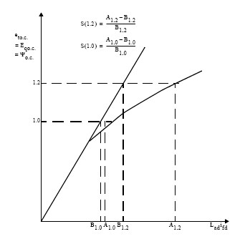

Magnetic saturation data to be assumed

S(1.0) =

S(1.2) =

**Annexure-II**

### Acceptable IEEE standard excitation model available with PSS/E simulation package used by POWERGRID

|  |  |
| --- | --- |
| **Excitation System Models** | |
| ESAC1A | 1992 IEEE type AC1A excitation system model |
| ESAC2A | 1992 IEEE type AC2A excitation system model |
| ESAC3A | 1992 IEEE type AC3A excitation system model |
| ESAC4A | 1992 IEEE type AC4A excitation system model |
| ESAC5A | 1992 IEEE type AC5A excitation system model |
| ESAC6A | 1992 IEEE type AC6A excitation system model |
| ESAC8B | Basler DECS model |
| ESDC1A | 1992 IEEE type DC1A excitation system model |
| ESDC2A | 1992 IEEE type DC2A excitation system model |
| ESST1A | 1992 IEEE type ST1A excitation system model |
| ESST2A | 1992 IEEE type ST2A excitation system model |
| ESST3A | 1992 IEEE type ST3A excitation system model |
| EXAC1 | 1981 IEEE type AC1 excitation system model |
| EXAC1A | Modified type AC1 excitation system model |
| EXAC2 | 1981 IEEE type AC2 excitation system model |
| EXAC3 | 1981 IEEE type AC3 excitation system model |
| EXAC4 | 1981 IEEE type AC4 excitation system model |
| EXBAS | Basler static voltage regulator feeding dc or ac rotating exciter model |
| EXDC2 | 1981 IEEE type DC2 excitation system model |
| EXELI | Static PI transformer fed excitation system model |
| EXPIC1 | Proportional/integral excitation system model |
| EXST1 | 1981 IEEE type ST1 excitation system model |
| EXST2 | 1981 IEEE type ST2 excitation system model |
| EXST2A | Modified 1981 IEEE type ST2 excitation system model |
| EXST3 | 1981 IEEE type ST3 excitation system model |
| IEEET1 | 1968 IEEE type 1 excitation system model |
| IEEET2 | 1968 IEEE type 2 excitation system model |
| IEEET3 | 1968 IEEE type 3 excitation system model |
| IEEET4 | 1968 IEEE type 4 excitation system model |
| IEEET5 | Modified 1968 IEEE type 4 excitation system model |
| IEEEX1 | 1979 IEEE type 1 excitation system model and 1981 IEEE type DC1 model |
| IEEEX2 | 1979 IEEE type 2 excitation system model |
| IEEEX3 | 1979 IEEE type 3 excitation system model |
| IEEEX4 | 1979 IEEE type 4 excitation system, 1981 IEEE type DC3 and 1992 IEEE type DC3A models |
| IEET1A | Modified 1968 IEEE type 1 excitation system model |
| IEET1B | Modified 1968 IEEE type 1 excitation system model |
| IEET5A | Modified 1968 IEEE type 4 excitation system model |
| IEEX2A | 1979 IEEE type 2A excitation system model |
| SCRX | Bus or solid fed SCR bridge excitation system model |
| SEXS | Simplified excitation system model |

**Annexure-III**

### SEXS – Simplified Excitation System Model

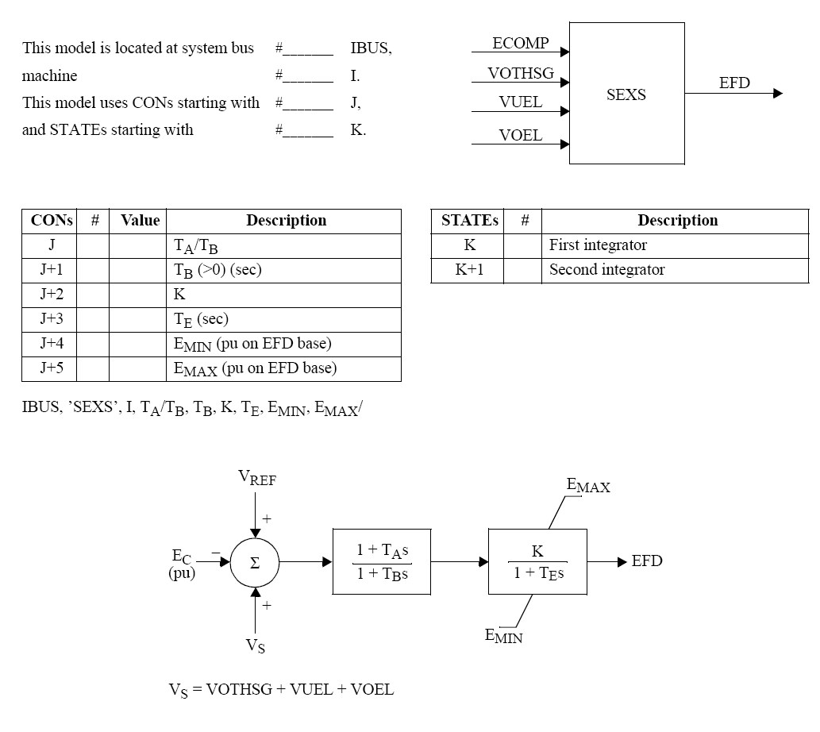

**Annexure - IV**

**Inverter Configurations:**

Inverters within a Solar farm can be present in different configurations, as indicated below:

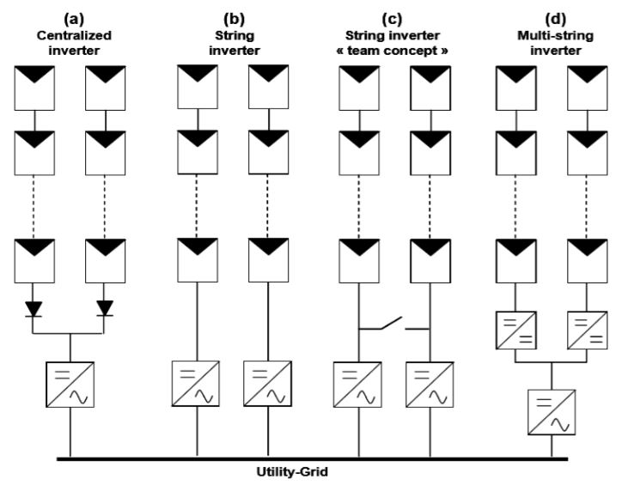

The data furnished must take into account the individual inverter configurations accordingly.

**Block Diagrams:**

1. **Generators:**

* **REGCA1:** Generic Model for Utility Scale Solar PV

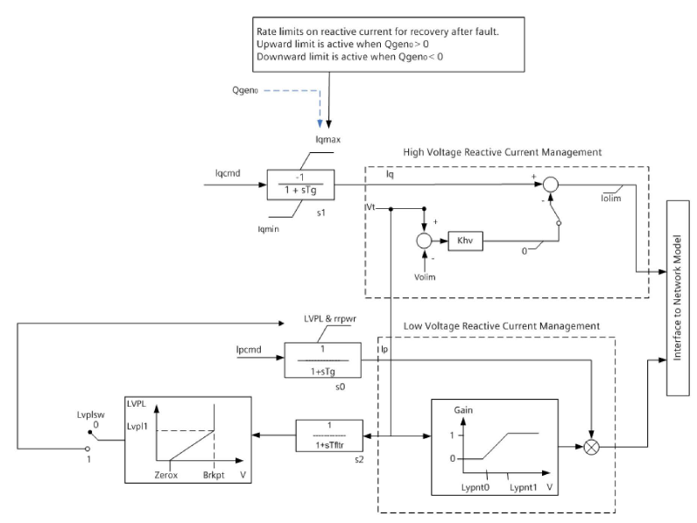

1. **Electrical Control:**

* **REECB1:** Generic Model for Utility Scale Solar PV

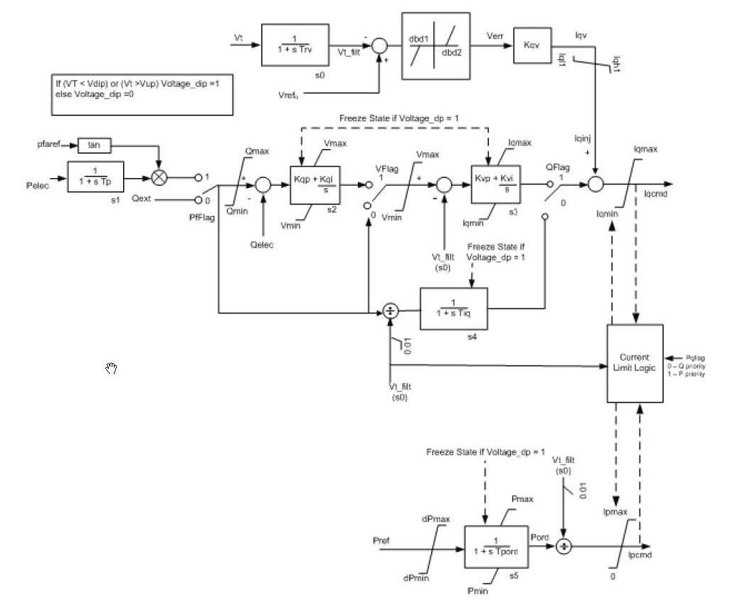

1. **Power Plant Controller (PPC) Model:**

* **REPCA1** for Utility scale Solar PV:

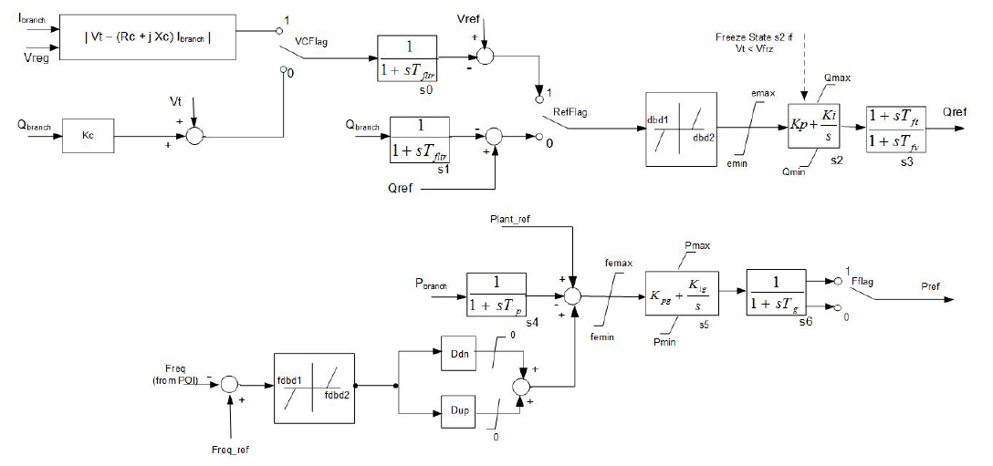

1. **Electrical Control Model for Utility Scale Battery Energy Storage System (BESS):**

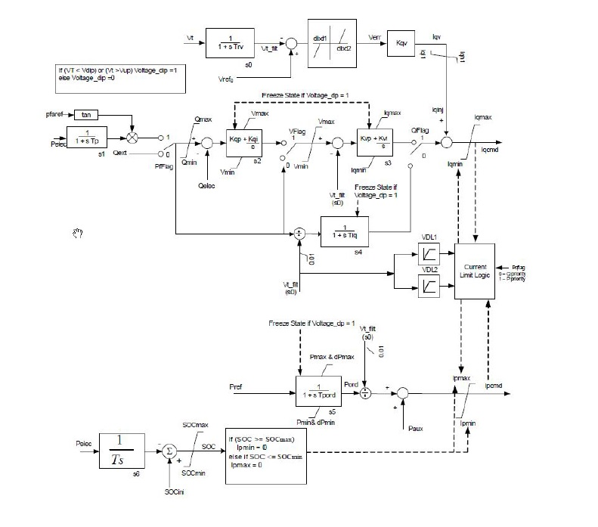

**Annexure – V**

**Block Diagrams**

1. **Generators:**

* REGCA1: Generic Model for Type-3 and Type-4 wind turbines



1. **Electrical Control:**

* Type-2 (WT2E1) : Rotor Resistance Control

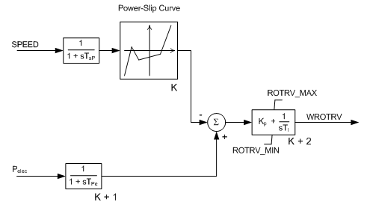

* Type-3 or Type-4 (REECA1) :

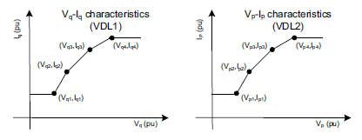

**Figure:** Vp-Ip and Vq-Iq curves for REECA1 model

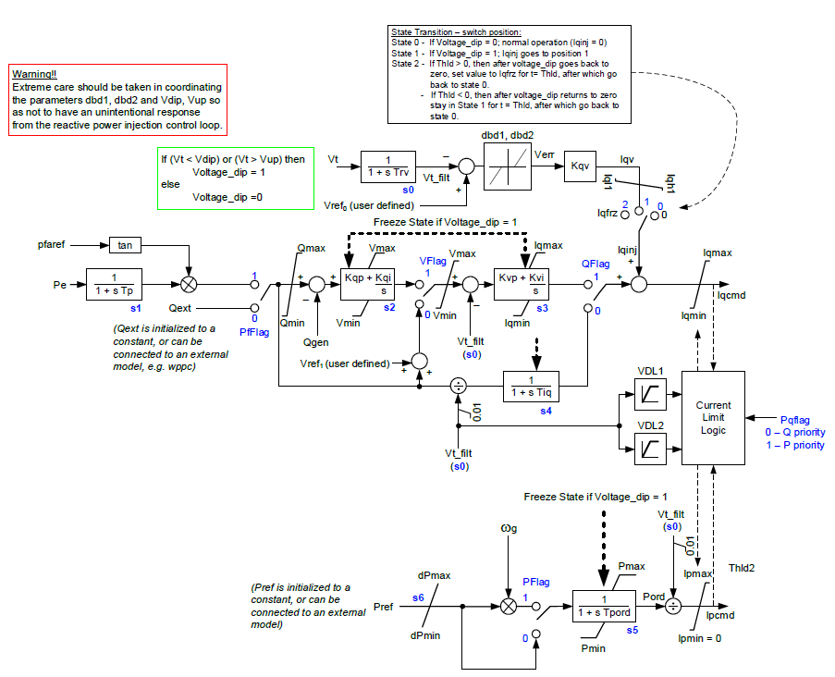

1. **Drive Train Model:**

* Type-2 (WT12T1) : For Type 1 and Type-2 wind turbines

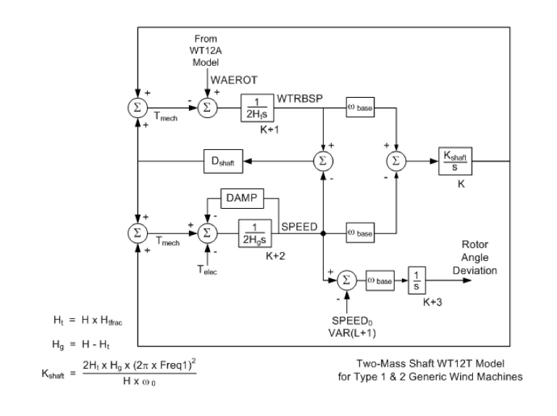

* WTDTA1 : Generic Drive Train model for Type-3 and Type-4 turbines

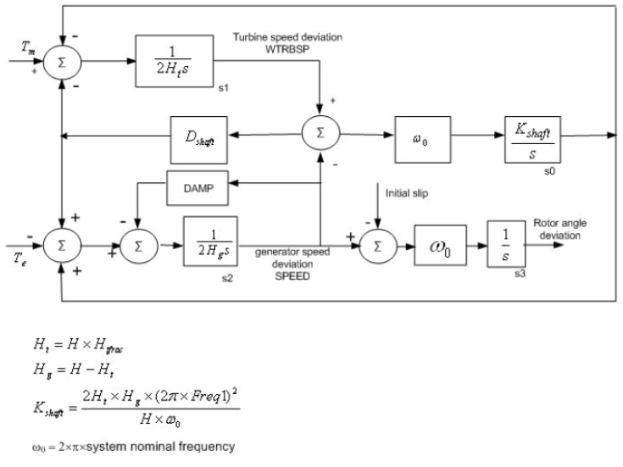

1. **Pitch Control:**

* Type-3 (WTPTA1) : Generic Pitch Control for Type-3 WTG

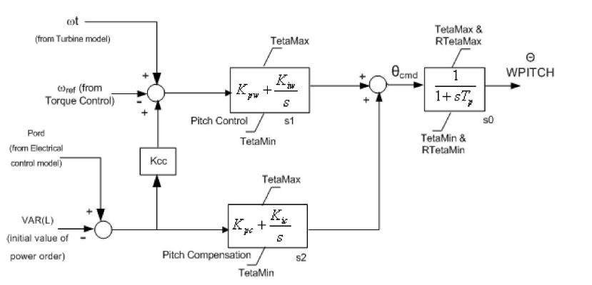

1. **Torque Controller Model:**

* Type-3 (WTTQA1) : Generic Torque Controller for Type-3 WTG

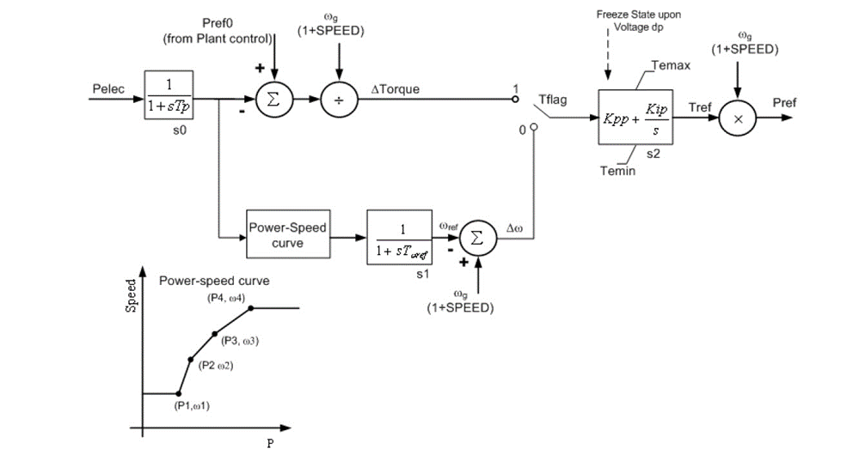

1. **Aerodynamic Model:**

* Type-3 (WTARA1) : Generic Aerodynamic model Type-3 WTG

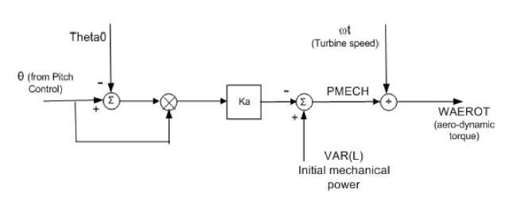

1. **Power Plant Controller (PPC) Model:**

* REPCTA1 for type 3, and REPCA1 for type 4 turbines



1. **Electrical Control Model for Utility Scale Battery Energy Storage System (BESS):**

